Day of Judgment

Surat Al-Fatihah
1:2
Sahih International
[All] praise is [due] to Allah, Lord of the worlds -

The word “Rabb” signifies ‘one who nurtures’ and ‘nurture’ implies developing a thing by gradual stages in a manner which is conducive to its own good till it attains perfection. The word, Rabb is exclusive to the sacred being of Allah, and cannot be employed in the case of any created being without adding some qualification, for a created being is itself in need of ‘nurture’, and cannot nurture anyone else.

Al-alamin is the plural of ‘alam (world, universe, kingdom). “The Worlds” include all possible forms of existence: the sky, the earth, the sun, the moon, stars, wind and rain, the angels, the jinns, animals, plants, minerals, and, of course, men. So the ‘Lord of all the worlds’ means that Allah alone gives nurture to all the forms of existents that are to be found in this universe in the outer space. Imam Razi, the great commentator of the Holy Quran, says that the existence of an indefinite space beyond our universe can be proved on the basis of rational argument, and it is also certain that Allah is All-powerful, so it should not be at all difficult for Him to have created millions of other universes in this endless space.

It has been reported from the companion of Messenger of Allah, Abu Said al-Khudri that there are forty thousand worlds; our world, stretching from the East to the West, is only one of them, there are many more besides it. According to the well-known commentator Muqatil, the number of worlds is eighty thousand.

Seen in the light of this short phrase, “Lord of the Worlds”, the universe reveals itself to be an incredibly complex, yet perfectly integrated order. From the heavens to the earth, from the planets and the stars to the particles of dust, everything is bound in a chain of being, and is performing the function assigned to it by Divine Wisdom.

Man cannot obtain a little morsel of food unless a thousand forces of the sky and the earth work together to produce it. The universal order is there for a man to contemplate, and to realize that, if Allah has put millions of His creates in the service of man, man in his turn cannot be worthless or purposeless or meaningless. The Holy Quran is indeed very explicit and very insistent in reminding us that the universe is not absurd:

Surat Sad
38:27
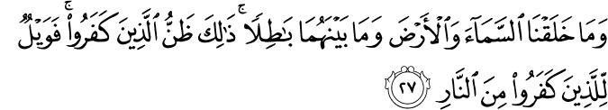
Sahih International
And We did not create the heaven and the earth and that between them aimlessly. That is the assumption of those who disbelieve so woe to those who disbelieve from the Fire.

If the universe is not in vain or absurd, man too, whose purpose the universe has been made to serve, cannot be a purposeless and meaningless. The holy Quran defines the purpose in creating man and the goal of his existence in these words:

Surat Adh-Dhariyat
51:56
Muhsin Khan
And I (Allah) created not the jinn’s and humans except they should worship Me (Alone).

1:4
Muhsin Khan
The Only Owner (and the Only Ruling Judge) of the Day of Recompense (i.e. the Day of Resurrection)

The word Malik has been derived from the root, ‘milk’ which signifies possessing a thing in such a manner that one has the right and power to dispose of it as one likes. The work Din signifies ‘Recompense’ or ‘Requital’. So the meaning of the ayat “Master of the Day of Requital” implies total mastery on the Day of Requital. But there is no mention of the thing or things to which this mastery or possession would apply. According to the commentary “al-kashshaf”, the phrase makes a general reference to cover everything. That is to say, on the Day of Requital the mastery over everything that exists will belong to Allah alone.

The Day of Requital [Judgment, Recompense] is real and rational:

What is the day of Requital/Judgment? Secondly, Allah being the master of everything even today as much as on the Day of Requital, why does this verse specifically mention the day of Judgment? The day of Judgment is the Day appointed by Allah to recompense good or evil deeds. The world is only the field of action, the place where one is required to perform one’s duty, and not the place for receiving one’s reward.

The mere fact that man happens to be healthy or wealthy or powerful does not necessarily argue that he has won the pleasure and favor of Allah. Similarly, the mere fact that a man happens to be ill or poor or weak or miserable does not by itself indicate that he is the object of Allah’s wrath. Even in the case of worldly life, would it not be platitude [meaning less remark especially uttered as if it were fresh or profound] to remark that a man sweating in a factory or an office does not consider it a misfortune. As a matter of fact, try to deprive him of this opportunity to sweat, and you would have earned his deepest displeasure; for beyond all this toil he can glimpse the reward he is going to get in the form of a pay check for his wages.

The greatest sufferings in this world are the lot of prophets and after them the men of Allah, and yet we see them quite content and even happy.

It may, however, happen that a man receives some punishment or reward for his deeds in this world. This never is the full recompense, but only a faint model which has manifested to serve as an intimation or warning. This is clearly mentioned in the Quran:

Surat Sajdah
32:21
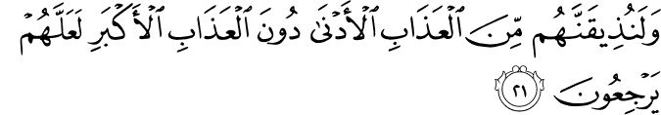
Muhsin Khan
And verily, We will make them taste of the near torment (i.e. the torment in the life of this world, i.e. disasters, calamities, etc.) prior to the supreme torment (in the Hereafter), in order that they may (repent and) return (i.e. accept Islam).

Surat Al-Qalam
68:33
Muhsin Khan
Such is the punishment (in this life), but truly, the punishment of the Hereafter is greater, if they but knew.
The sufferings of this world, as even its joys, are sometimes a trial, and sometimes a punishment, but never a full recompense, for the world is itself transitory. What really counts in the joy or suffering that will endure for ever, and which one will come to know in the other world. Given the fact that the good or evil deeds are not fully recompensed in this world, every deed, big or small, good or evil, is to be judged, and then justly rewarded or punished. The whole idea has been explained by the Holy Quran itself:

Surat Ghafir
40:58
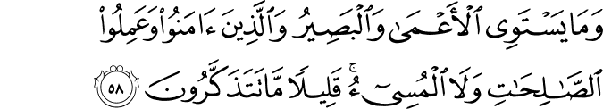
Muhsin Khan
And not equal are the blind and those who see, nor are (equal) those who believe (in the Oneness of Allah Islamic Monotheism), and do righteous good deeds, and those who do evil. Little do you remember!
40:59
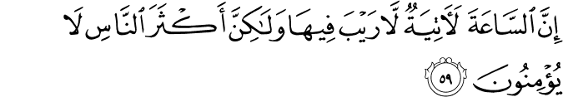
Muhsin Khan
Verily, the Hour (Day of Judgment) is surely coming, therein is no doubt, yet most men believe not.

Allah is the real Master of the whole creation, not only on the Day of Judgment but even now. Why does the ayat of Surat Fatihah refer specifically to the Day of Judgment? The real and complete mastery over everything, no doubt belongs to Allah alone even in this world. Yet Allah Himself, in His beneficence and wisdom, has granted a kind of imperfect, temporary and apparent mastery to man as well; and the shariah in laying down laws for wordly affairs, has given due consideration to man’s limited right to ownership.

But today, in possessing land or money or power, which has been given to him by way of trial, man has always been prone to get drunk with pride and vanity. The phrase “Master of the Day of Judgment” is a warning to man reeling in his forgetfulness and self-conceit, and an intimation that all his possession, all his relationships with things and men are only short-lived, and that there shall come a Day when master will no more be master and slaves no more slaves, when no one will own anything even in appearance, and the ownership and master, apparent as well as real, of the whole universe will be seen to belong to none but Allah, the Exalted. The Holy Quran says:

Surat Ghafir
40:17
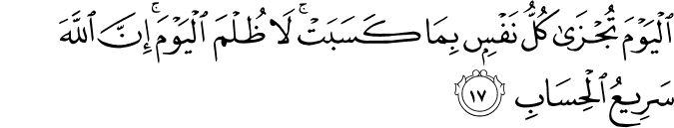
Muhsin Khan
This Day shall every person be recompensed for what he earned. No injustice (shall be done to anybody). Truly, Allah is Swift in reckoning.

Surat An-Naziat

79:42
Muhsin Khan
They ask you (O Muhammad (Peace be upon him)) about the Hour, - when will be its appointed time?
79:43
Muhsin Khan
You have no knowledge to say anything about it,
79:44
Muhsin Khan
To your Lord belongs (the knowledge of) the term thereof?
79:45
Muhsin Khan
You (O Muhammad (Peace be upon him)) are only a warner for those who fear it,
79:46
Muhsin Khan
The Day they see it, (it will be) as if they had not tarried (in this world) except an afternoon or a morning.

Surat Al-'A`raf
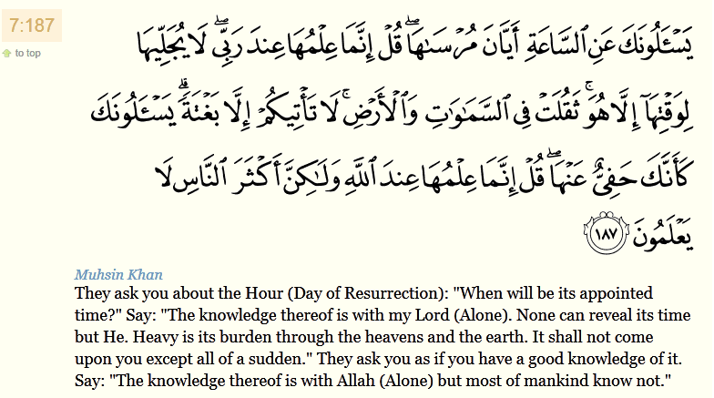

Surat Al-Qamar
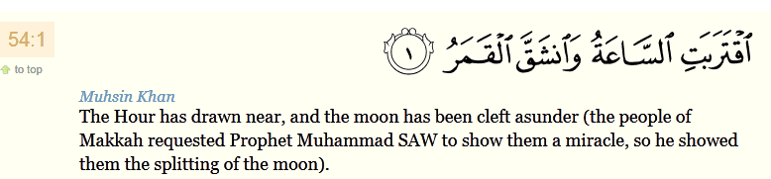

Surat Ash-Shura
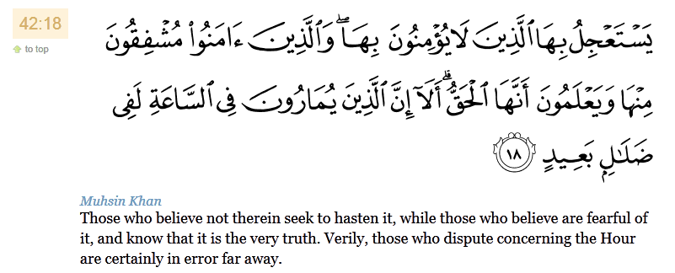

The Hadith – When Compared To The Time That Has Passed, The Day Of Resurrection Is Indeed Near

Abdullah Ibn Umar related that he heard the Messenger of Allah say he was standing on the Minbar (pulpit), “Indeed, your remaining in comparison to those who came before you from the nations is like the time between the ‘Asr prayer and setting of the sun. The people of the Torah were given the Torah, and they applied it until the middle of the day, and then they became incapable. They were given a Qeerat (a measurement, indicating a great reward). Then the people of the Injeel (Bible) were given the Injeel, and they applied it until the ‘Asr prayer; they were given Qeerat Qeerat. Then you were given the Quran, and you applied it until the setting of the sun, and you were given two Qeerats. The people of the Torah and the Injeel said, ‘Our Lord, these are less in work, but greater in reward’. He said, ‘Did I wrong you in anything regarding your wages?’ They said, ‘No’, He said, ‘then that is My Favor, which I bestow upon whomsoever I please.” [Ahmad] [Bukhari related it as well, but through a different chain.

On the day of resurrection, The Muslim will be resurrected with those whom he loves

A Bedouin once asked the Messenger of Allah about the hour, and the prophet said, "Indeed it is happening (i.e. it will certainly come to pass), and what preparation have you made for it? The man said, "By Allah, O Messenger of Allah, I have not prepared much in terms of prayer or action, but I do indeed love Allah and His Messenger". The prophet said, “You are with those whom you loved". [Muslim]. The Muslims never became as happy about something as they became with this Hadith.

Whoever Dies, Then His Last Hour Has Arrived

In some narrations, it is related that when the prophet was asked about the hour, he turned to a young boy and said: "He will not reach old-age until the Hour of all of you comes to you" [Muslim]
This means that their generation will become extinct and they will all have entered into the world of the Hereafter: Whoever dies, then for him his Day of Resurrection has arrived. As for the great hour, when the first and last will be gathered on a plane, the timing thereof is something that Allah alone knows.

The Messenger of Allah Did Not Know The Time Of The Hour

When Jibreel came in the form of a Bedouin and asked the prophet about Islam, then Emaan, and then Ihsaan, the prophet answered him. But when Jibreel asked about the Hour, the Prophet said, "The one who is questioned does not have more knowledge about it than the questioner."

Abu Hurairah related that the Messenger of Allah said, "When spoils and trusts are taken as booty; when zakaat is considered to be a burden (or tax); when knowledge is learned, but not for the religion; when a man obeys his wife but disobeys his mother, brings close his friend while keeping his father at a distance; when voices are raised in the mosques; when the tribe is led by the most wicked one among them; when the leader of a people is the most base individual among them; when a man is honored because of his evil is feared; when female singers and musical instruments spread; when alcohol is imbibed; and when the last of this nation curses the first of it - at that point, wait for a red wind, for the sinking of the earth, for Qadhr (two opinions: flying of the stones with severe winds or the expelling of the corpse of the deceased after its burial), and for signs that will follow in sequence like the beads of an old necklace after its string is cut - and they fall in sequence" (At-Tirmidhee)

Abu Hurairah related that the Prophet said: "We are the last (of the nations) and the first on the Day of Resurrection, and we are the first to enter Paradise." (Bukhari, Muslim, and An-Nasaaee, and the wording of the above narration is taken from An-Nasaaee).

Umar ibn Khattab related that the Messenger of Allah said, "Indeed Paradise is forbidden for all of the prophets until I enter it (first); and it is forbidden upon all nations until my nation enters it (first)".

The following is established in Bukhari & Muslim: "Allah will say: Admit into Paradise whoever from you nation has no reckoning upon him through the Baab Al-Ayman (a door of paradise); and they will be participating with people in all the doors as well."

In another narration, Abu Hurairah related that the Messenger Of Allah said, "Whoever spends a pair from his wealth (a pair is referring to any two things from the same type of wealth) in the way of Allah, he will be called from the gates of Paradise, and Paradise has gates. So whosoever is from the people of prayer, then he is called from the gate of Prayer. So, whosoever is from the people of charity (Sadaqah), he is called from the gate of charity; so, whosoever is from the people of Jihaad is called from the gate of Jihaad; So, whosoever is from the people of fasting is called from the gate of Ar-Rayyan." Abu Bakr said, "By Allah … will there be one who is called from all of them, O Messenger of Allah" He said, "Yes, and I hope that you will be one of them" (Bukhari & Muslim)

Sahl ibn Sa'ad related that the Messenger of Allah said, "In Paradise there are eight gates, one of which is called Ar-Rayyaan; none will enter it except the people of fasting. When they will have entered through it, it will be closed and none other than them shall enter through it. [Bukhari & Muslim]

The Poor Will Enter Paradise Before The Rich

Abu Hurairah related that the Messenger of Allah said, "Poor Muslims will enter Paradise before rich (Muslims) by a period of half a day (of the Hereafter), and that is 500 years (from this world)" [Ahmad]

Ibn Abbas related that the Messenger of Allah said, "Two believers met at the door of a Paradise, a rich believer and a poor believer - (such were) they in the world. The poor believer was made to enter Paradise while the rich believer was made to enter Paradise; the poor man met him and said: "O my brother, what has held you back" By Allah, you were restrained until I began to fear for you.". He said, 'My brother, after you (entered paradise), my detainment was severe and unpleasant. I have only reached you after so much sweat poured from me that, were 1000 camels to come (to that sweat as a place of drinking) after each one of them ate something sour (to make them thirsty), they would have been quenched by it." [Ahmad]

Usaamah ibn Zaid related that the Messenger of Allah said, "I stood at the gate of Paradise, and (I saw that) most of those who entered it were the Masaakeen (the poor). And I stood at the gate of Hell, and (I saw that) most of those who entered it were women." [Bukhari & Muslim]

Anas ibn Malik related that the Prophet said, "The Hour will not come until people vie with one another regarding mosques (perhaps meaning that the will compete with another in building beautiful mosques of extravagant designs - nd Allah knows best). [Ahmad]

In another narration 'Aleem said, "We were seated on a roof and with us was a man from the Prophets companions." Yazeed said, "I do not know him except as 'Ans Al-Ghaffaaree. People were deep in discussion on the plague and 'Ans said, 'O Plague, take me.' He said it three times. 'Aleem said, 'Why do you say that? Did not the Messenger of Allah say, 'None of you should hope for death, for with death one's deeds come to an end, and even if one asks for it to be delayed (when its time comes) it will not be prevented.'

Aleem said, 'Verily, I heard the Messenger of Allah say, 'Hasten to death before the following: the coming of foolish rulers; and increase in the number of special guards (for the ruler); the selling of judgments (i.e. judgements are purchased through bribery); blood being deemed insignificant (i.e., much killing, without people considering there to be value to life); the breaking of family ties; and the presence of a group that takes the Quran as a flute (i.e., saying it in a melodious but affected and extravagant manner), gives it to the people, and diverts them with it (from the true purpose of the Qu'ran), though they have the least understanding among them.'"

Surah Al-Mu’minun
23:12
Muhsin Khan
And indeed We created man (Adam) out of an extract of clay (water and earth).
23:13
Muhsin Khan
Thereafter We made him (the offspring of Adam) as a Nutfah (mixed drops of the male and female sexual discharge) (and lodged it) in a safe lodging (womb of the woman).
23:14
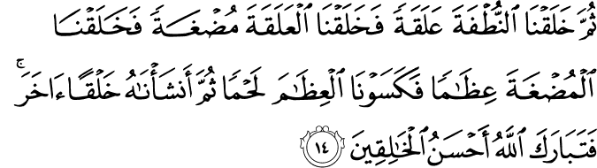
Muhsin Khan
Then We made the Nutfah into a clot (a piece of thick coagulated blood), then We made the clot into a little lump of flesh, then We made out of that little lump of flesh bones, then We clothed the bones with flesh, and then We brought it forth as another creation. So blessed be Allah, the Best of creators.
23:15
Muhsin Khan
After that, surely, you will die.
23:16
Muhsin Khan
Then (again), surely, you will be resurrected on the Day of Resurrection.
23:17
Muhsin Khan
And indeed We have created above you seven heavens (one over the other), and We are never unaware of the creation.

Surah Ar-Rum
30:27
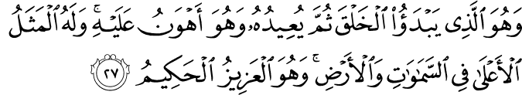
Muhsin Khan
And He it is Who originates the creation, then will repeat it (after it has been perished), and this is easier for Him. His is the highest description (i.e. none has the right to be worshipped but He, and there is nothing comparable unto Him) in the heavens and in the earth. And He is the All-Mighty, the All-Wise.

Surah Al-Ankabut
29:20
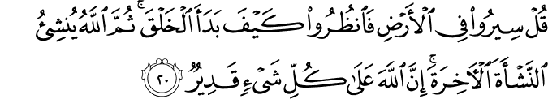
Muhsin Khan
Say: "Travel in the land and see how (Allah) originated creation, and then Allah will bring forth (resurrect) the creation of the Hereafter (i.e. resurrection after death). Verily, Allah is Able to do all things."

Surah Az-zukhruf
43:11
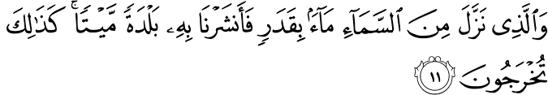
Muhsin Khan
And Who sends down water (rain) from the sky in due measure. Then We revive a dead land therewith, and even so you will be brought forth (from the dead),

Surah Fatir
35:9
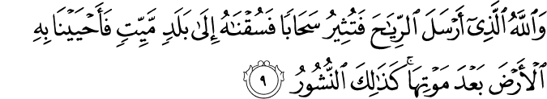
Muhsin Khan
And it is Allah Who sends the winds, so that they raise up the clouds, and We drive them to a dead land, and revive therewith the earth after its death. As such (will be) the Resurrection!
35:10
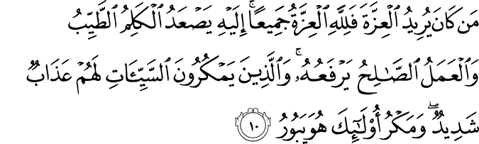
Muhsin Khan
Whosoever desires honor, power and glory then to Allah belong all honor, power and glory [and one can get honor, power and glory only by obeying and worshipping Allah (Alone)]. To Him ascend (all) the goodly words, and the righteous deeds exalt it (the goodly words i.e. the goodly words are not accepted by Allah unless and until they are followed by good deeds), but those who plot evils, theirs will be severe torment. And the plotting of such will perish.

35:11
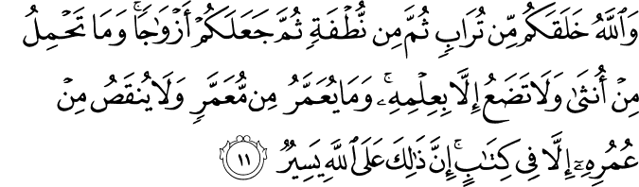
Muhsin Khan
And Allah did create you (Adam) from dust, then from Nutfah (male and female discharge semen drops i.e. Adam's offspring), then He made you pairs (male and female). And no female conceives or gives birth, but with His Knowledge. And no aged man is granted a length of life, nor is a part cut off from his life (or another man's life), but is in a Book (AlLauh AlMahfuz) Surely, that is easy for Allah.

Surat At-Tariq
86:5
Muhsin Khan
So let man see from what he is created!
86:6
Muhsin Khan
He is created from water gushing forth.
86:7
Muhsin Khan
Proceeding from between the back-bone and the ribs,
86:8
Muhsin Khan
Verily, (Allah) is Able to bring him back (to life)!
86:9
Muhsin Khan
The Day when all the secrets (deeds, prayers, fasting, etc.) will be examined (as to their truth).
86:10
Muhsin Khan
Then will (man) have no power, nor any helper.
86:11
Muhsin Khan
By the sky (having rain clouds) which gives rain, again and again.
86:12
Muhsin Khan
And the earth which splits (with the growth of trees and plants),
86:13
Muhsin Khan
Verily! This (the Quran) is the Word that separates (the truth from falsehood, and commands strict legal laws for mankind to cut the roots of evil).
86:14
Muhsin Khan
And it is not a thing for amusement.

Surat Al-Araf

7:57
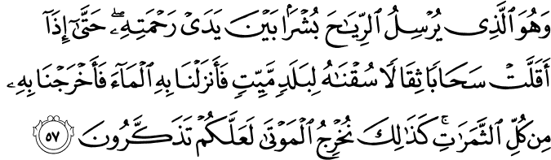
Muhsin Khan
And it is He Who sends the winds as heralds of glad tidings, going before His Mercy (rain). Till when they have carried a heavy-laden cloud, We drive it to a land that is dead, then We cause water (rain) to descend thereon. Then We produce every kind of fruit therewith. Similarly, We shall raise up the dead, so that you may remember or take heed.

Surat Qaf

50:3
Muhsin Khan
"When we are dead and have become dust (shall we be resurrected?) That is a far return."
50:4
to top
Muhsin Khan
We know that which the earth takes of them (their dead bodies), and with Us is a Book preserved (i.e. the Book of Decrees).

Surat Al-Waqiah

56:58
Muhsin Khan
Then tell Me (about) the human semen that you emit.
56:59
Muhsin Khan
Is it you who create it (i.e. make this semen into a perfect human being), or are We the Creator?
56:60
Muhsin Khan
We have decreed death to you all, and We are not unable,
56:61
Muhsin Khan
To transfigure you and create you in (forms) that you know not.
56:62
Muhsin Khan
And indeed, you have already known the first form of creation (i.e. the creation of Adam), why then do you not remember or take heed?

Surat Al-Insan

76:28
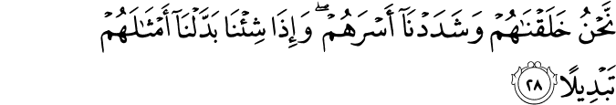
Muhsin Khan
It is We Who created them, and We have made them of strong built. And when We will, We can replace them with others like them with a complete replacement.

Surat Al-Ma’arij
70:39
Muhsin Khan
No, that is not like that! Verily, We have created them out of that which they know!
70:40
Muhsin Khan
So I swear by the Lord of all [the three hundred and sixty (360)] points of sunrise and sunset in the east and the west that surely We are Able
70:41
Muhsin Khan
To replace them by (others) better than them; and We are not to be outrun.

Surat Al-Isra

17:49
Muhsin Khan
And they say: "When we are bones and fragments (destroyed), should we really be resurrected (to be) a new creation?"
17:50
Muhsin Khan
Say (O Muhammad SAW) "Be you stones or iron,"
17:51
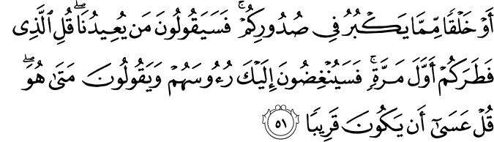
Muhsin Khan
"Or some created thing that is yet greater (or harder) in your breasts (thoughts to be resurrected, even then you shall be resurrected)" Then, they will say: "Who shall bring us back (to life)?" Say: "He Who created you first!" Then, they will shake their heads at you and say: "When will that be ?" Say: "Perhaps it is near!"
17:52
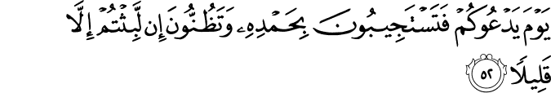
Muhsin Khan
On the Day when He will call you, and you will answer (His Call) with (words of) His Praise and Obedience, and you will think that you have stayed (in this world) but a little while!

Surat an-Naziat

79:10
Muhsin Khan
They say: "Shall we indeed be returned to (our) former state of life?
79:11
Muhsin Khan
"Even after we are crumbled bones?"
79:12
Muhsin Khan
They say: "It would in that case, be a return with loss!"
79:13
Muhsin Khan
But only, it will be a single Zajrah [shout (i.e., the second blowing of the Trumpet)]. (See Verse 37:19).
79:14
Muhsin Khan
When, behold, they find themselves over the earth alive after their death,

Surat Al-Baqarah

2:259
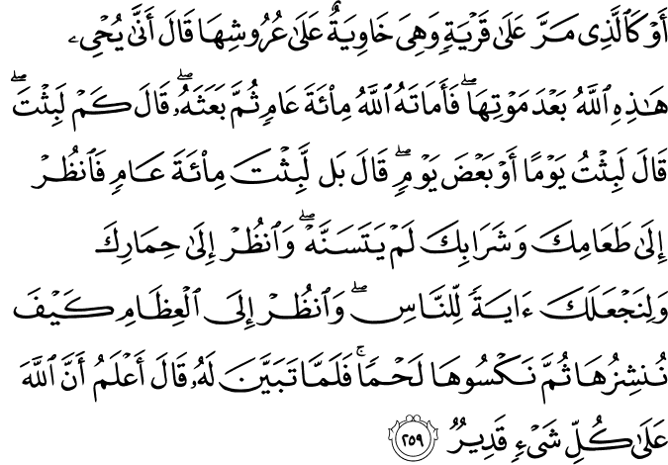
Muhsin Khan
Or like the one who passed by a town and it had tumbled over its roofs. He said: "Oh! How will Allah ever bring it to life after its death?" So Allah caused him to die for a hundred years, then raised him up (again). He said: "How long did you remain (dead)?" He (the man) said: "(Perhaps) I remained (dead) a day or part of a day". He said: "Nay, you have remained (dead) for a hundred years, look at your food and your drink, they show no change; and look at your donkey! And thus We have made of you a sign for the people. Look at the bones, how We bring them together and clothe them with flesh". When this was clearly shown to him, he said, "I know (now) that Allah is Able to do all things."
2:260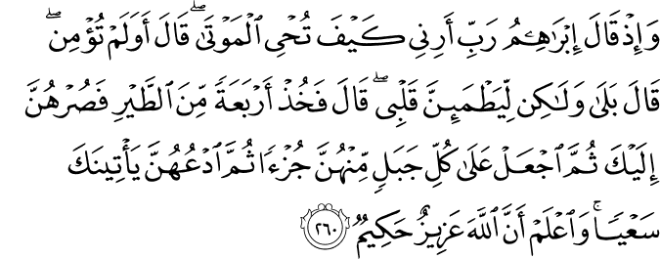
Muhsin Khan
And (remember) when Ibrahim (Abraham) said, "My Lord! Show me how You give life to the dead." He (Allah) said: "Do you not believe?" He [Ibrahim (Abraham)] said: "Yes (I believe), but to be stronger in Faith." He said: "Take four birds, then cause them to incline towards you (then slaughter them, cut them into pieces), and then put a portion of them on every hill, and call them, they will come to you in haste. And know that Allah is All-Mighty, All-Wise."

Allah mentioned the people of the cave story and how they woke up from a sleep that lasted for 300 sun years – which is equal to 309 moon years. Allah said regarding that:

Surah Al-Kahf

18:21
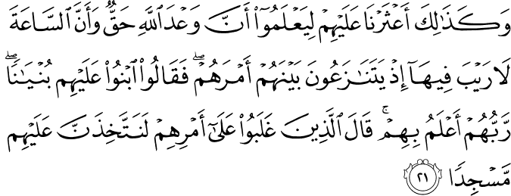
Muhsin Khan
And thus We made their case known to the people, that they might know that the Promise of Allah is true, and that there can be no doubt about the Hour. (Remember) when they (the people of the city) disputed among themselves about their case, they said: "Construct a building over them, their Lord knows best about them," (then) those who won their point said (most probably the disbelievers): "We verily shall build a place of worship over them."

The End Of This World And The Coming Of The Hereafter

After the occurrence of all the signs, the first matter to overcome the people of this world is the blowing of terror, and that occurs when Allah orders Israfeel to blow the trumpet – this blowing is the blowing of terror. It will be looked at, and none shall remain from the people of the earth except that he raises his neck and then lowers, hearing the great matter, which will have terrified the people and caused them great anxiety. Referring to the occurrence of this tremendous matter, Allah said:

Surat An-Naml
27:87
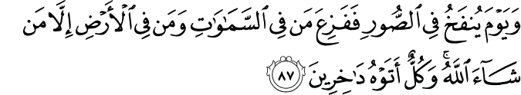
Muhsin Khan
And (remember) the Day on which the Trumpet will be blown and all who are in the heavens and all who are on the earth, will be terrified except him whom Allah will (exempt). And all shall come to Him humbled.
27:88
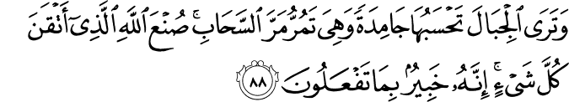
Muhsin Khan
And you will see the mountains and think them solid, but they shall pass away as the passing away of the clouds. The Work of Allah, Who perfected all things, verily! He is Well-Acquainted with what you do.

Surat Sad

38:15
Muhsin Khan
And these only wait for a single Saihah [shout (i.e. the blowing of the Trumpet by the angel Israfil Sarafil)] there will be no pause or ending thereto [till everything will perish except Allah (the only God full of Majesty, Bounty and Honour)].

Surat Al-Muddaththir (The Cloaked One) -

74:8
Muhsin Khan
Then, when the Trumpet is sounded (i.e. its second blowing);
74:9
Muhsin Khan
Truly, that Day will be a Hard Day.
74:10
Muhsin Khan
Far from easy for the disbelievers.

Surat Al-Anam

6:73
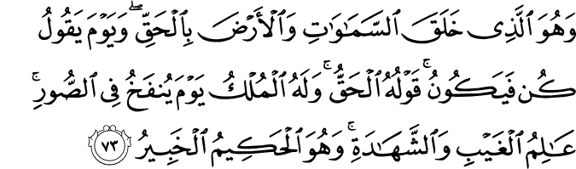
Muhsin Khan
It is He Who has created the heavens and the earth in truth, and on the Day (i.e. the Day of Resurrection) He will say: "Be!", - and it shall become. His Word is the truth. His will be the dominion on the Day when the trumpet will be blown. All-Knower of the unseen and the seen. He is the All-Wise, Well-Aware (of all things).

Then after a while, Allah will make His command and the trumpet will be blown, and all in the heavens and the earth, except for those whom Allah wills, will swoon away. Then Allah will order Israfeel a second time, and people will stand for the Lord of all that exists.

Surat Az-Zumar

39:68
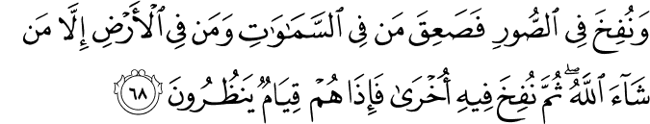
Muhsin Khan
And the Trumpet will be blown, and all who are in the heavens and all who are on the earth will swoon away, except him whom Allah will. Then it will blown a second time and behold, they will be standing, looking on (waiting).

39:69
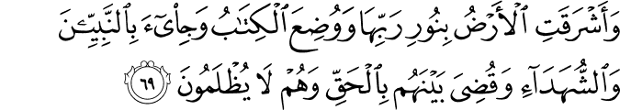
Muhsin Khan
And the earth will shine with the light of its Lord (Allah, when He will come to judge among men) and the Book will be placed (open) and the Prophets and the witnesses will be brought forward, and it will be judged between them with truth, and they will not be wronged.
39:70
Muhsin Khan
And each person will be paid in full of what he did; and He is Best Aware of what they do.
Surat Ya-Seen
36:48
Muhsin Khan
And they say: "When will this promise (i.e. Resurrection) be fulfilled, if you are truthful?"
36:49
Muhsin Khan
They await only but a single Saihah (shout, etc.), which will seize them while they are disputing!
36:50
Muhsin Khan
Then they will not be able to make bequest, nor they will return to their family.
36:51
Muhsin Khan
And the Trumpet will be blown (i.e. the second blowing) and behold! From the graves they will come out quickly to their Lord.
36:52
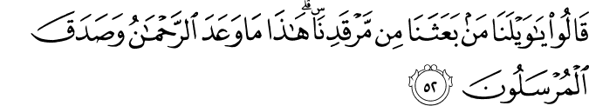
Muhsin Khan
They will say: "Woe to us! Who has raised us up from our place of sleep." (It will be said to them): "This is what the Most Beneficent (Allah) had promised, and the Messengers spoke truth!"

Surat An-Naziat
79:13
Muhsin Khan
But only, it will be a single Zajrah [shout (i.e., the second blowing of the Trumpet)]. (See Verse 37:19).
Surat Al-Qamar
54:50
Muhsin Khan
And Our Commandment is but one, as the twinkling of an eye.
Surat Al-Kahf

18:99
Sahih International
And We will leave them that day surging over each other, and [then] the Horn will be blown, and We will assemble them in [one] assembly.

Surat Al-Haqqah
69:13
Muhsin Khan
Then when the Trumpet will be blown with one blowing (the first one),
69:14
Muhsin Khan
And the earth and the mountains shall be removed from their places, and crushed with a single crushing,
69:15
Muhsin Khan
Then on that Day shall the (Great) Event befall,
69:16
Muhsin Khan
And the heaven will split asunder, for that Day it (the heaven will be frail (weak), and torn up,
69:17
Muhsin Khan
And the angels will be on its sides, and eight angels will, that Day, bear the Throne of your Lord above them.
69:18
Muhsin Khan
That Day shall you be brought to Judgment, not a secret of you will be hidden.

Surat An-Naba
78:18
Muhsin Khan
The Day when the Trumpet will be blown, and you shall come forth in crowds (groups);
78:19
Muhsin Khan
And the heaven shall be opened, and it will become as gates,
78:20
Muhsin Khan
And the mountains shall be moved away from their places and they will be as if they were a mirage.
Surat Taha
20:102
Muhsin Khan
The Day when the Trumpet will be blown (the second blowing): that Day, We shall gather the Mujrimun (criminals, polytheists, sinners, disbelievers in the Oneness of Allah, etc.) Zurqa: (blue or blind eyed with black faces).

Abdullah ibn Amr said, “A Bedouin said, ‘O Messenger of Allah, what is As-Soor? He said, ‘It is a horn that is blown’’. [Ahmad]

The Hour Will Arrive Between One Instant And Another
Through another chain, At-Tirmidhee, An-Nisaaee, and, Abu Dawood related it as well, and At-Tirmidhee said,”Hasan, and we do not know it except from the Hadith of Aslam Al-Ijlee”. And regarding the verse: “Then, when the trumpet is sounded i.e., the second blowing)”, Ibn Abbas reported that the Messenger of Allah said, “How can I be comfortable when the one of the horn has taken the horn (by his mouth) and has inclined his forehead waiting – for the time he will be ordered, and then he will blow.” The companions of Rasul-Allah said, ‘O Messenger of Allah, what should we say?” He said, “Say: Sufficient is Allah for us and the most blessed Wakeel (Protector), and we place our complete trust in Allah.” [Ahmad]

Abu Saeed Al-Khudree said, “The Messenger of Allah mentioned the one of horn [Angel] and said, ‘On his right is Jibreel, and on his left is Meekaael – upon them prayers and salutations.” [Ahmad]

Abdullah Ibn ‘Umar related that the Prophet said, “The two blowers are in the second Heaven; the head of one of them is in the West and his two legs are in the east. They are waiting for the time that they will be ordered to blow into the horn, so that they will then blow”. [Ahmad]. One of the narrators of this Hadith, Abu Miryah, is not famous. Regarding these two angels, perhaps one of them is Israfeel, and he is the one who will blow in the horn; we will further clarify this in the Hadith of the horn, in its full length. The other one will blow in the Naqoor, which might be the horn. Naqoor is a general term, under which there may be many individual elements. Each one of the two said angels will have followers, doing what he does. And Allah knows best what is correct.

Ibn Abbas related that the Messenger of Allah said, “The holder of the trumpet has not blinked since it was assigned to him. He is looking toward the Arsh (Throne), fearing that he will be ordered before he is finished blinking – it is as if his two eyes are glistening stars”. Ibn Abee Ad-Dunyaa related this narration as well.

The Hadith Of The Horn In Its Full Length, With A Description Of Some Of The Events That Will Take Place On The Day Of Resurrection

Abu Hurairah said that, while the Messenger of Allah was among a group of his companions, he said, “Indeed, when Allah finished creating the heavens and the earth, He created the horn (Trumpet) and gave it to Israafeel. He holds it on his mouth, looking at the ‘Arsh [Throne] with his sight, waiting for when he will be ordered.” Abu Hurairah asked “O Messenger of Allah, and what is As-Soor?” He said, “A horn.” “And what is it like?” He said, “Huge. And by the One who has sent me by the truth, the greatness of the circle of his mouth is like the width of the heavens and the earth. He will blow into it three times: the first is the blowing of terror; the second is the blowing of swooning away; and the third is the blowing of resurrection to the Lord of all that exists. Allah will order Israafeel to make the first blowing, saying, ‘Blow the blowing of terror’. The inhabitants of the heaven and the earth will be terrified except for whomsoever Allah pleases. Allah will order him, and then he will extend it and prolong it without getting tired. This blowing is the one about which Allah said:

Surat Sad
38:15
Muhsin Khan
And these only wait for a single Saihah [shout (i.e. the blowing of the Trumpet by the angel Israfil Sarafil)] there will be no pause or ending thereto [till everything will perish except Allah (the only God full of Majesty, Bounty and Honour)].

Surat An-Naziat
79:6
Muhsin Khan
On the Day (when the first blowing of the Trumpet is blown), the earth and the mountains will shake violently (and everybody will die),
79:7
Muhsin Khan
The second blowing of the Trumpet follows it (and everybody will be raised up),
79:8
Muhsin Khan
(Some) hearts that Day will shake with fear and anxiety.

The earth will shake with its inhabitants; every nursing mother will forget her nursling and every pregnant one will drop her load. Children will turn gray-haired, and people will fly; fleeing from the terror. The angels will meet them, striking them on their faces, and they will return. They will turn around, running away. They will have no protector from Allah. Some of them will call others, and, while they are upon that state, the earth will split into two cracks, from one region to another. They will see a tremendous matter, never having seen before something similar to it. And for that they will fall into such a state of terror and grief that only Allah has full knowledge thereof. They will at the sky, and it will be like the boiling filth of oil, (or molten copper or silver or lead etc.,). Then the sky will be cleft asunder and the stars will be scattered. The sun and its moon will be eclipsed.” The, Messenger of Allah said, The dead will know nothing of that.”

Abu Hurairah said, “As for those whom Allah exempted when He said, ‘and all who are in the heavens and all who are on the earth, will be terrified except him whom Allah will (exempt),’ They are the Shuhadaah [Martyrs]. The terror reaches only those who are alive, and the shuhadaah are alive with their Lord, and they are being given provision. Allah will protect them from the terror of that day, making them safe. It will be a punishment from Allah that he will send upon the worst of the creation. About this terror, Allah said:

Surat Al-Hajj

22:1
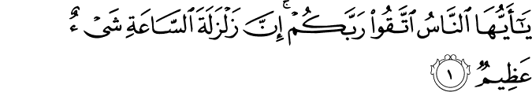
Muhsin Khan
O mankind! Fear your Lord and be dutiful to Him! Verily, the earthquake of the Hour (of Judgment) is a terrible thing.

22:2
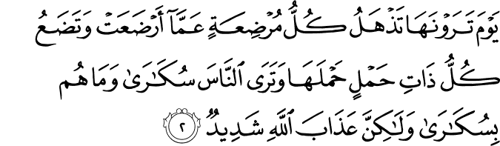
Muhsin Khan
The Day you shall see it, every nursing mother will forget her nursling, and every pregnant one will drop her load, and you shall see mankind as in a drunken state, yet they will not be drunken, but severe will be the Torment of Allah.

“They will remain in that state of punishment for a period that Allah wills; and it will be prolonged. Then Allah will order Israafeel to blow the blowing of swooning away. Except for those whom Allah wills, the inhabitants of the heaven and the earth will swoon away. Any they will be silent (dead, destroyed). The angel of death will go to the All-Mighty and say, ‘O my Lord, other than those whom You exempted, the inhabitants of the heavens and the earth are dead.’ He will say, and He is most knowledgeable regarding who remains, ‘And who is left.’ The angel will say, ‘O my Lord, You, the Ever-Living, Who never dies, remains. The bearers of Your throne remain; Jibreel and Meekaaeel remain; and I remain.’
Allah says, ‘Let Jibreel and Meekaaeel die’. Then Allah will make His Throne speak, and it will say, ‘O my Lord, Jibreel and Meekaaeel will die?’ Allah will say, ‘Be quiet, for I have indeed written death upon everyone who is under my Throne.’ And so the two said angels will die. Then the angel of death goes to the All-Mighty ‘Azza Wa-Jall (to Whom belongs Might and Majesty), and says, ‘O my Lord, Jibreel and Meekaaeel have indeed died. I and the bearers of the throne are left.’ Allah will say, ‘Then let the bearers of the throne die,’ and they will die. And Allah will order the throne, and it will seize the horn from Israafeel. Then the angel of death will go to All-Mighty and say, O my Lord, the bearers of Your throne have indeed died.’ He will say, and He is most knowledgeable regarding who remains, “Then who is left?” He will say, ‘O my Lord, You, the Ever-Living, Who never dies remains, and I remain.’ Allah will say, ‘You are one of my creation; I have created you for what you have seen, so die, and he will die. When no one remains except for Allah the One, the Irresistible, the One, the single Self-Sufficient Master (Whom all creatures need, He neither eats nor drinks) : He begets not, nor was He begotten. And there is none c0-equal or comparable to Him. He will be the Last just as He was the First. He will fold the heavens and the earth like the folding of the registry for a book. Then he will spread them and then wrap them three times. He will say, I am the All-Mighty (Al-Jabbar),’ three times. Then He will call with His voice, ‘Whose is the kingdom this Day?’ He will call out (with this question) three times, no one will answer Him. He will say to Himself, ‘It is Allah’s, the One, the irresistible!’. The earth will be changed to another earth and so will be the heavens. Then He will unfold, even out, spread, and then extend it, like the extending of tanned leather… You will see therein nothing crooked or curved. Then Allah will drive out the creation with one driving, and they will be like they were the first time: whoever was inside of it will be inside it, and whoever was on it will be on it. Then Allah will send water from underneath the Throne on you. Then Allah will order the sky to give rain, and it will rain for forty days, until the water will be above them by 12 arm-spans. Then Allah will order bodies to grow, and they will grow like the growing of vegetables, until their bodies will be complete, becoming as they were. Allah will say, ‘Let Jibreel and Meekaaeel live,’ and they will come back to life. Then Allah will call the souls. They will be brought, and they will be shining; the souls of Muslims are light; and the (souls of the) others are dark. He will seize them all and throw them into the horn (Trumpet). Then Allah will order Israafeel to blow the blowing of resurrection, and he will blow the blowing of resurrection. The souls will come out as if they were bees; they will have filled what is between the heavens and the earth. Allah will say, ‘By My Greatness and Majesty, each soul will indeed return to its body. The souls will enter the earth to the bodies, and they will enter into the noses, moving in the body like poison in a poisonous (creature). Then the earth will split for you, and I am the first person for whom the earth will split. You will come out in a hurry, going quickly to your Lord:

Surat Al-Qamar
54:8
Muhsin Khan
Hastening towards the caller, the disbelievers will say: "This is a hard Day."

“You will be bare footed, naked, Ghulfan, Ghurlan (uncircumcised). Then you will stand in one place of standing for a period of seventy years, and you will not be looked at. Nor will any judgment be passed between you. Then you will cry until your tears are depleted. Then you will cry blood and you will sweat, until that (sweat) bridles you (i.e., reaches your faces, just as a bridle does for a horse) or it will reach the chins (of some). Then you will shout, saying, ‘Who will intercede for us to our Lord, so that He judges between us?’ They will say, ‘Who is worthy than your father, Adam. Allah created him with His Hand, and He blew into him from His Rooh, and He spoke to him Qublan.’ They will go to Adam and request that from him, but he will refuse…Then they will go to the Prophets, one Prophet at a time. Each time they go to a Prophet, he will refuse them.”
The Messenger of Allah said, until you come to me, and I will go until I reach Al-Fahs, where I will fall down, prostrating.” Abu Huraira said, “O Messenger of Allah, what is Al-Fahs?” He said, “A place before the Throne; until Allah sends an angel to me, who will take me by my upper arm. He will raise me and say to me, ‘O Muhammad.’ I will say (to Allah), ‘Yes, I am answering your call, O my Lord.’ Allah will say, ‘What is your affair?’ – and He is Most knowledgeable thereof, I will say, ‘O my Lord, You promised me intercession, so allow me to intercede for Your creation – so judge between them.’ He will say, ‘I have granted your intercession. I am coming to you all and I will judge among you.”
The Messenger of Allah said, “I will then return and stand with the people. As we are standing, we will hear a powerful sound from the sky. The inhabitants of the heaven of the earth will descend, (in number) like those who are on earth from jinn and mankind. When they come near to the earth, the earth will shine with their light. And they will take their places in rows. We will say to them. ‘Is our Lord among you?’ They will say, ‘No, He is coming.’…Until the All Mighty –Blessed is He, The Exalted – will come in the shadows of the clouds and the angels. At that time, eight will carry His Throne; and today there are four. Then Allah will call out with His voice, saying ‘O group of jinn and mankind; indeed, I have listened to you from the day you were created until this day of yours; I have listened to your speech and seen your deeds, so listen to Me. Verily, it is only your deeds and your scrolls that are read out to you. Whosoever finds goodness then let him praise Allah. And whosoever finds otherwise, then let him blame no one except himself. Then Allah will order the Hell fire, and a manifest dark neck will come out from it. Then He will say:
Surat Ya-seen
36:59
Muhsin Khan
(It will be said): "And O you Al-Mujrimun (criminals, polytheists, sinners, disbelievers in the Islamic Monotheism, wicked evil ones, etc.)! Get you apart this Day (from the believers).
36:60
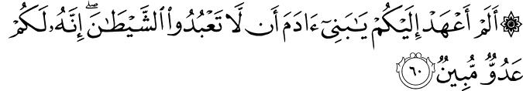
Muhsin Khan
Did I not ordain for you, O Children of Adam, that you should not worship Shaitan (Satan). Verily, he is a plain enemy to you.
36:61
Muhsin Khan
And that you should worship Me [Alone Islamic Monotheism, and set up not rivals, associate-gods with Me]. That is a Straight Path.
36:62
Muhsin Khan
And indeed he (Satan) did lead astray a great multitude of you. Did you not, then, understand?

36:63
Muhsin Khan
This is Hell which you were promised!
36:64
Muhsin Khan
Burn therein this Day, for that you used to disbelieve.
Allah will separate the people, making each group distinct. He will call the nations, calling each nation to its Book. And the nations will be kneeling from the terror (of the situation). Allah said:

Surat Al-Jāthiyah (The Crouching)
45:28
Muhsin Khan
And you will see each nation humbled to their knees (kneeling), each nation will be called to its Record (of deeds). This Day you shall be recompensed for what you used to do.

“Then Allah will rule between the creation except for Ath-Thaqalain: mankind and jinn. Allah will rule between wild beasts and animals, to the degree that the hornless animal will extract retribution from the horned one. When Allah finishes that, and there remains no liability upon anyone else (from other than jinn and mankind), Allah will say to them (to beasts and animals): ‘Be you all dust’. At that juncture, the disbelievers will say, ‘Would that I were dust’. Then Allah will rule between (His) slaves, and the first matter that will be ruled upon will be (issues of) blood. Everyone who was killed in the way of Allah will come, and Allah will command the one who killed, and he will carry his head (i.e. the head of the one who was killed; (blood) will be coming out from its veins. He will say, ‘O my Lord, I killed him so that the Glory be Yours’. Allah will say, ‘You have spoken the truth.’ Then Allah will make his face become like the light of the heavens, and then the angels will precede him to Paradise. Then all will be brought who were killed for other reasons. He will command the one who killed, and he will carry the head of the one who was killed, the veins of which will spill blood. He will say, ‘O my Lord, for what did this kill me?’ Allah will say, and He knows best, ‘For what did you kill him?’ He will say, ‘O my Lord, I killed him so that the glory be mine.’ Allah will say, ‘You have become wretched (or destroyed; or be wretched)’. There will remain no soul that was killed by a killer except that it will be killed for, nor will any transgression remain that one person wronged another with, except that Allah will take it for the wronged from the transgressor, to the degree that one who mixed milk with water will be called upon to purify the milk from the water. When Allah finishes that, then a caller will call out, and all of the creation will hear him. He will say, ‘Let every people go to their gods and those that they worshipped other than Allah will be given a shape before him: at that time an angel from the angels will be made to take the appearance of ‘Uzair; and another angel will be made to take the appearance of ‘Easa. The former will be followed by the jews, and the latter will be followed by the Christians. Then all of their (false) gods will steer them to the Fire. About this, Allah said:

Surat Al-'Anbyā' (The Prophets)
21:99
Muhsin Khan
Had these (idols, etc.) been aliha (gods), they would not have entered there (Hell), and all of them will abide therein.

“When only the believers remain, the hypocrites will remain among them. Allah will come to them upon whatsoever form He pleases. He will say, ‘O people, the people have went, so catch up to your gods and to whatever you worshipped.’ They will say, ‘By Allah, we have no one save Allah: we would not worship anyone save Him.’ Then he will leave them – and He is Allah – and they remain for what period Allah wills for them to remain. Then He will come to them and say, ‘O people, the people have gone, so catch up with your gods and with those you used to worship.’ They will say, ‘By Allah, we have no one save Allah, and we would not worship anyone save Him.’ He will reveal His Shim to them, and such of His Greatness will become plain to them that they will know that He is their Lord. They will fall down, prostrating on their faces. Every hypocrite will fall on the back of his neck, and Allah will make their spinal columns become like the horns of cows (i.e. they will not be able to bend). Then Allah will give permission to them, and they will raise their heads. And Allah will place the Siraat (path) over Paradise, like a strap of hair or a knot of hair or like the blade of a sword. Upon it will be hooks and grapples and hard thorns of steel like the thorns of Sa’daan (a kind of thorny plant). Before it is a bridge that is slick and slippery. They will pass over it like the blinking of an eye, like the flash of lightning, like the passing of wind, like racing horses, like other racing animals, or like racing men. Some will go by safely, some will be safe but scratched, and some will be pushed onto their faces into the Hellfire. When the people of paradise will reach paradise, they will say, ‘Who will intercede for us to our Lord, so that He will make us enter paradise?’ They will say, ‘Who is more worthy of that than your father, Adam? Indeed Allah created him with His Hand and blew into him from His Rooh, and spoke to him Qublan (directly)’. They will go to Adam and request that from him. He will mention a sin and say, ‘I am not the one for that, but go to Nooh, for he is the first of His Messengers to His creation.’ They will go to Nooh and request that from him, but he will mention something and say, ‘I am not the one for that, but you should go to Moosa.’ They will make that request to him, but he will mention a sin and say, ‘I am not the one for that, but you should go to Roohullah (a spirit created by Allah) and His word (i.e. He said, “be” – and he was), ‘Eesa Ibn Maryam.’ They will request that from him, but he will say, I am not the one for that, but you should go to Muhammad.’ The Messenger of Allah said, Then they will come to me, and for me are three intercessions that my Lord promised. Then I will go to Paradise and take the ring of the door. Next, I will ask for it to be opened, and it will be opened for me. I will be greeted and welcomed. When I enter paradise, I will look at my Lord ‘Azza Wa-Jall (to whom belongs Might and Majesty) and I will fall down to Him, prostrating. Allah will inform me of something from His praise and glorification that He never before informed to anyone from His creation. Then Allah will say to me, ‘Raise your head, O Muhammad, and intercede, for you will be granted intercession. And ask, for you will be given.’ When I will raise my head, Allah will say, and He knows best¸’What is your affair?’ I will say, ‘O my Lord, you promised me intercession, so grant it to me for the inhabitants of Paradise, so that they enter Paradise. Allah ‘Azza Wa-Jall (to whom belongs Might and Majesty) will say, ‘I have granted you intercession, and I have given permission for them to enter paradise.” The Messenger of Allah used to say, “By the One who has sent me by the Truth, you do not recognize your wives and abodes in this world as well as the inhabitants of Paradise will recognize their wives and abodes.”

“Each man from them will enter upon 72 wives as Allah created them (i.e. Allah created them for the dwellers of Paradise; they are not women who lived in the world), and two will be Adamiyyatain (two from the children of Adam). Because of their worship of Allah in the world, they will have the favor of whomsoever Allah pleases. He (the dweller of Paradise) will enter upon one of the two in a room made of sapphire (or ruby), upon a bed made of gold, wreathed in pearls. He will have 70 levels of fine and thick silk. He will place his hand between her shoulders and then look from her chest to what is behind her garment in terms of skin and flesh. And he will indeed look at the flesh of her shin. His liver will be as a mirror to her and her liver will be as a mirror to him. While he is with her – he does not tire of her nor does she tire of him – it will be called out, ‘We indeed know that you do not tire and that she does not tire (or become bored), but you have wives other than her.’ Then he will go out, going to them one by one. Every time he goes to one, she will say, ‘By Allah, there is none in Paradise who is more beloved to me than you.” He said, “And when the people of Hellfire fall into the Hellfire, some among your Lord’s creation will fall into it – their deeds will have destroyed them. As for some of them, (the fire) will take them until their feet, not going beyond that from them; others it will take until the loins; and yet others it will take their entire body, except for the face”. The Messenger of Allah said, “I will say, ‘O my Lord, grant me intercession for those from my Nation who entered into the Hellfire.’ Allah ‘Azza Wa-Jall (to Whom belongs Might and Majesty) will say, ‘Take out those you know.’ And they will come out, until not a single one from them remains. Then Allah will give me permission to intercede. There will remain no prophet or martyr except that he intercedes. Then Allah will say, ‘Take out the one in whose heart you find Emaan equal to the weight of a Deenar.’ Those will come out, until not a single one from them remains. Then intercession will be sought from Allah, and He will say, ‘Take out the one in whose heart you fine Emaan equal to two-thirds of Deenar’. Then he will say, ‘One-third’. Then He will say, ‘A Qeeraat’ Then He will say, ‘A mustard seed.’ They will come out until there remains no one in the Hellfire who ever did even a single deed for Allah, and until there remains no one who is granted intercession except after his intercession is granted. Even Iblees will stand tall from what he sees of Allah’s mercy, hoping that he will be interceded for. Then Allah will say, ‘I remain, and I am the Most Merciful of the merciful ones. He will enter His Hand into the Hellfire and take out an amount that none can enumerate except He as if they are grain. Allah will spread them on a river that is called the River of the Animals. And they will grow.. From beside a green sun and a shade that has yellowness to it. They will grow until they become the likes of pearls. Written on their necks is Al-Jahannamiyyoon (the Hellfire ones), the ones freed by the Most Merciful ‘Azza Wa-Jall (to Whom belongs Might and Majesty). The people of paradise will know them by that writing. They never did any good for Allah, and they will remain in Paradise.”

The Different Time That The Horn is Blown, And Nothing Remains From a Human Being Except for ‘Ajbudh-Dhanab (The Lowest Bone On The Spinal Cord)

The horn (or Trumpet) will be blown three times: the blowing of the terror, the blowing of the swooning away, and the blowing of the resurrection.

Abu Hurairah related that the Messenger of Allah said, “Between the two times the horn is blown is forty.” Abu Hurairah was asked, “Forty days?” He said, “I refuse (i.e. I refuse to comment on this, for I cannot say for sure whether it is forty days, months or years. All that I know is that it is forty).” Then he was asked, “Forty Months?”. He said, “I refuse” then he was asked Forty years?” And he said, “I refuse.” The Prophet then said, “Then Allah sends water down from the sky, and they (mankind) will grow like vegetables. And everything from man decomposes except for one bone. ‘Ajbudh-Dhanab’ (the lowest bone on the spinal cord), and from it the creation will be made again on the Day of Resurrection.” [Muslim]. Bukhari related the same through a different chain of narrators.

Abu Saeed reported that the Messenger of Allah said, The earth will eat all parts of man except for Ajbudh-Dhanab (the lowest bone on the spinal cord).” It was said, “And what is it, O Messenger of Allah?” The Messenger of Allah said, “Like a mustard kernel, and from it they will grow.”

From The Terrors Of The Day Of Resurrection

One such terror is the shaking of the earth and its inhabitants, which will rock them to the left and to the right. Allah said:

Surat Az-Zalzalah (The Earthquake)

99:1

Muhsin Khan
When the earth is shaken with its (final) earthquake.
99:2
Muhsin Khan
And when the earth throws out its burdens,
99:3
Muhsin Khan
And man will say: "What is the matter with it?"

Surat Al-Ĥaj
22:1
Muhsin Khan
O mankind! Fear your Lord and be dutiful to Him! Verily, the earthquake of the Hour (of Judgement) is a terrible thing.
22:2
Muhsin Khan
The Day you shall see it, every nursing mother will forget her nursling and every pregnant one will drop her load, and you shall see mankind as in a drunken state, yet they will not be drunken, but severe will be the Torment of Allah.

Surat Al-Wāqi`ah (The Inevitable)
56:1
Muhsin Khan
When the Event (i.e. the Day of Resurrection) befalls.
56:2
Muhsin Khan
And there can be no denying of its befalling.
56:3
Muhsin Khan
It will bring low (some); (and others) it will exalt;
56:4
Muhsin Khan
When the earth will be shaken with a terrible shake.
56:5
Muhsin Khan
And the mountains will be powdered to dust.
56:6
Muhsin Khan
So that they will become floating dust particles.
56:7
Muhsin Khan
And you (all) will be in three kinds (i.e. separate groups)

Because the blowing of terror is from the very early stages of the Resurrection, the name, ‘The Day of Resurrection’ is appropriate to it and to what follows. Abu Hurairah related that the Messenger of Allah said, “And the Hour shall arrive when two men will have a spread a garment between them, but they will not make the transaction for it, nor will they fold it. The Hour will indeed arrive when a man goes with the milk of his Liqhah (camel that gives a lot of milk) but he will not taste it. And the Hour will indeed arrive when one is plastering his basin, but he will not drink from it. And the Hour will indeed arrive when one raises food to his mouth but he will not taste it. (Bukhari)

This applies to what is before the blowing of the terror, so that blowing is here referred to as the Hour and that is because it is from its early stages. We have previously related the Hadith in which it is mentioned that the people of the end of times are worst of people upon them the Hour will arrive.

In the previous Hadith of the horn that is related by Ibn Raafai’, it is mentioned that the sky will be cleft asunder between the blowing of the terror and the blowing of the swooning away; also the stars will scatter, and the sun and the moon will be eclipsed. What is apparent – and Allah knows best – is that this will be after the blowing of the swooning away. Allah said:

Surat 'Ibrahim
14:48
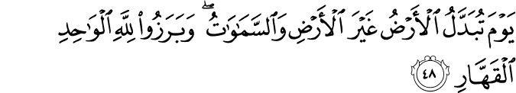
Muhsin Khan
On the Day when the earth will be changed to another earth and so will be the heavens and they (all creatures) will appear before Allah, the One, the Irresistible.
14:49
Muhsin Khan
And you will see the Mujrimun (criminals, disbelievers in the Oneness of Allah Islamic Monotheism, polytheists, disobedient to Allah, etc.) that Day bound together in fetters; [Muqarranun in fetters; mean:- with their hands and feet tied to their necks with chains.]
14:50
Muhsin Khan
Their garments will be of pitch, and fire will cover their faces.

Surat Al-'Inshiqāq
84:1
Muhsin Khan
When the heaven is split asunder
84:2
Muhsin Khan
And listens and obeys its Lord, and it must do so;

Surat Al-Qiyāmah
75:7
Muhsin Khan
So, when the sight shall be dazed,
75:8
Muhsin Khan
And the moon will be eclipsed,
75:9
Muhsin Khan
And the sun and moon will be joined together (by going one into the other or folded up or deprived of their light, etc.)
75:10
Muhsin Khan
On that Day man will say: "Where (is the refuge) to flee?"
75:11
Muhsin Khan
No! There is no refuge!
75:12
Muhsin Khan
Unto your Lord (Alone) will be the place of rest that Day.
75:13
Muhsin Khan
On that Day man will be informed of what he sent forward (of his evil or good deeds), and what he left behind (of his good or evil traditions).
75:14
Muhsin Khan
Nay! Man will be a witness against himself [as his body parts (skin, hands, legs, etc.) will speak about his deeds].
75:15
Muhsin Khan
Though he may put forth his excuses (to cover his evil deeds).

Page: 230 – page 114 in the pdf.

